## Letter of Recommendation for Maan Dhirendra Jain -

**To Whom It May Concern,**

I am writing this letter in strong recommendation of Maan Dhirendra Jain, a highly motivated and dedicated student in his 6th semester of Electronics and Telecommunication Engineering at Government Engineering College Raipur. I have had the pleasure of knowing Maan as his B.Tech for the past 2 years and am confident that he would be an exceptional asset to the Outreach Program at IIIT Naya Raipur.

Maan possesses a strong academic background in VLSI and embedded systems, evident in his publication of a review article on "VLSI Power Dissipation" at an international conference. This accomplishment demonstrates his research aptitude and in-depth knowledge of the field. Furthermore, Maan actively participated in a VLSI workshop organized by the IEEE EDS student branch chapter at NIT Raipur, reflecting his commitment to practical application of his theoretical knowledge.

Maan's thirst for continuous learning is commendable. He has successfully completed several online courses on VLSI and Embedded Systems from the prestigious NPTEL platform. His experience as an IoT trainer at DRM Raipur highlights his ability to not only grasp complex concepts but also effectively communicate them to others.

Maan's selection for a Workshop on Antenna at the Indian Institute of Information Technology and Management (IIITM), Gwalior, demonstrates his eagerness to broaden his skillset and explore related technical domains. Additionally, his impressive achievement of securing the 3rd position at the Smart Indian Hackathon showcases his problem-solving abilities and the ability to thrive in a competitive environment.

Maan is a highly motivated and dependable student with excellent communication and interpersonal skills. He is a team player who actively contributes to discussions and readily takes initiative. I am confident that Maan's strong technical foundation, research experience, and passion for learning make him an ideal candidate for the IIIT Naya Raipur Outreach Program. He is eager to contribute and possesses the dedication to excel in this program.

Please do not hesitate to contact me if you require any further information.

Sincerely,

[Your Name]

[Your Title]

Government Engineering College Raipur

/// 2nd

## Letter of Recommendation for Maan Dhirendra Jain - IIIT Naya Raipur Outreach Program

**To Whom It May Concern,**

I am writing to recommend Maan Dhirendra Jain, a standout student in his 6th semester of Electronics and Telecommunication Engineering at Government Engineering College Raipur, for the IIIT Naya Raipur Outreach Program. Maan's impressive academic record (7.54 SPI) is complemented by his research aptitude (published review article on "VLSI Power Dissipation") and practical experience (VLSI workshop participation, IoT trainer).

Maan's commitment to continuous learning (NPTEL courses) and his ability to excel in competitive environments (3rd place at Smart Indian Hackathon) make him a strong candidate. His selection for an Antenna Workshop at IIITM Gwalior further demonstrates his drive to broaden his knowledge.

Maan is a motivated team player with excellent communication skills. I highly recommend him for this program.

Sincerely,

[Your Name]

[Your Title]

Government Engineering College Raipur

Block Diagram



### Description:

* **Control & Analysis System**: Oversees the entire test bench operation, coordinating data flow and user interactions.
* **Data Processing Unit (DPU)**:
  + **Raw Data Acquisition**: Collects data from sensors and vehicle components.
  + **Data Filtering & Transformation**: Cleans and processes raw data.
  + **Processed Data Storage**: Stores transformed data for analysis.
  + **User Interaction for Data Export**: Allows users to export relevant data.
* **Data Visualization Module**: Generates visual representations of performance metrics.
* **Alerting System Module**: Notifies users of critical events or anomalies.

System Architecture

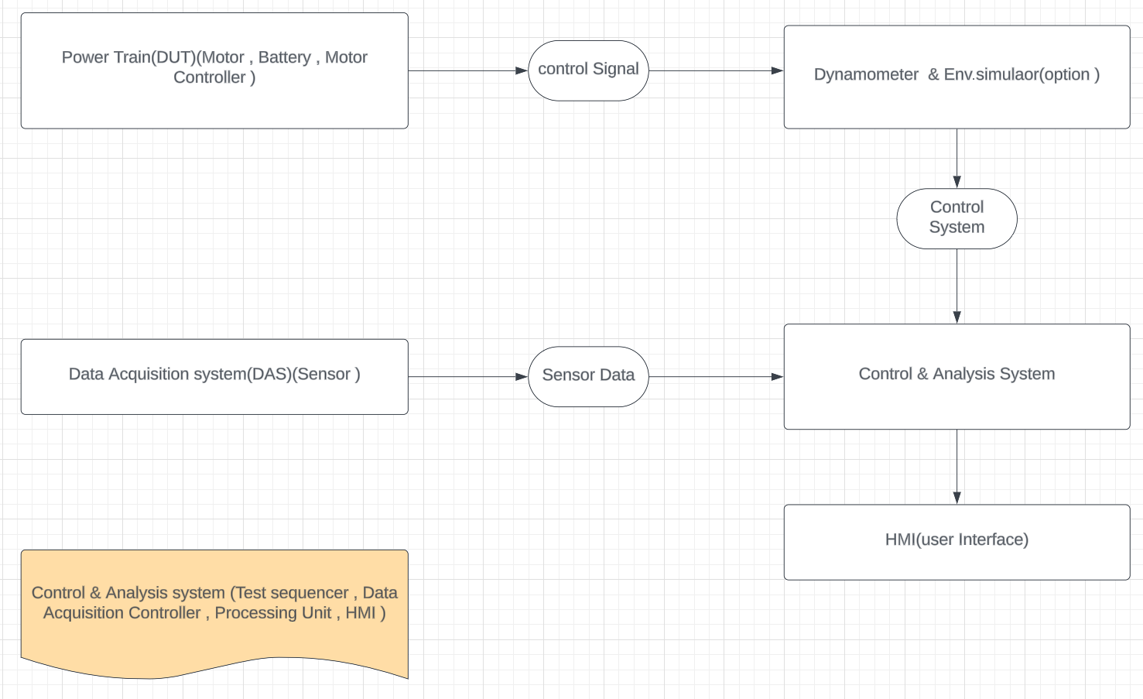

System Architecture

The EV Test Bench will be a modular system comprised of four key subsystems:

**Powertrain Under Test (DUT)**: This includes the electric motor, battery pack, and motor controller from the 2-wheeler EV being tested.

**Dynamometer & Environmental Simulator**: This subsystem simulates the driving conditions experienced by the EV, including load (torque and speed), road grade, and ambient temperature. It will consist of a programmable dynamometer and an environmental chamber (optional).

**Data Acquisition System (DAS):**This subsystem gathers data from various sensors on the DUT and dynamometer. It will include sensors for:

* Motor current & voltage
* Battery voltage & current
* Motor temperature
* Battery temperature
* Dynamometer speed & torque
* Ambient temperature (if using chamber)

**Control & Analysis System:**This subsystem controls the operation of the test bench, processes acquired data, and provides real-time and post-test analysis. It consists of:

**Test Sequencer**: Manages the execution of pre-defined test cycles.

**Data Acquisition Controller:**Interfaces with sensors and transmits data.

**Processing Unit:**Performs real-time calculations and analysis.

Human Machine Interface (HMI): Provides a user interface for test control, data visualization, and analysis reports.

**Additional Descriptions**

* Communication protocols: The system will utilize industry-standard communication protocols like CAN bus for efficient data exchange between subsystems.
* Data security: The system will be designed with data security measures to protect sensitive test data.
* Scalability: The design will consider future expansion by allowing for the addition of new sensors or test conditions.

This system architecture provides a modular and scalable framework for the EV Test Bench, facilitating comprehensive evaluation and optimization of the EV powertrain.

Dash Board

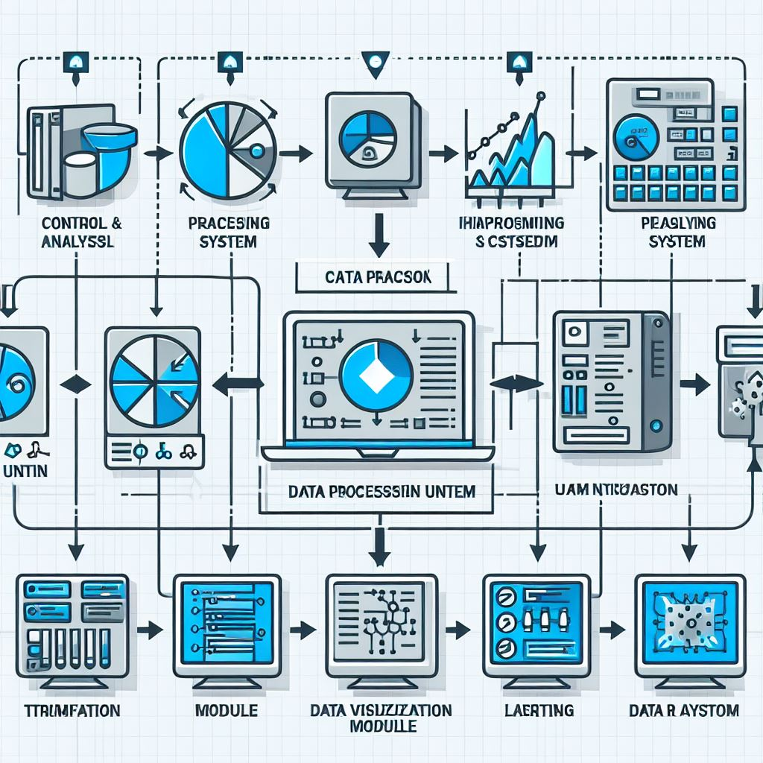

Data Dashboard for EV Test Bench

The data dashboard for the EV Test Bench should be designed for clarity, allowing for quick identification of key performance indicators (KPIs) and trends. Here's a possible layout:

Layout:

* The dashboard can be divided into sections based on functionalities:
* Test Information:
* Test name and description
* Date and time of test
* DUT configuration (motor, battery type, etc.)
* Powertrain Performance:

Motor:

* Real-time motor speed (RPM) and torque (Nm)
* Motor efficiency (%)
* Motor temperature (°C)

Battery:

* Battery voltage (V) and current (A)
* Battery State of Charge (SOC) (%)
* Battery health metrics (optional)
* Dynamometer & Environment:
* Dynamometer speed (RPM) and torque (Nm) setpoint vs. actual
* Road grade simulation (%) (if applicable)
* Ambient temperature (°C) (if using environmental chamber)

Performance Analysis:

* Efficiency Trend: Line graph showing overall powertrain efficiency over time
* Power vs. Speed Curve: Plot of motor power output vs. motor speed
* Energy Consumption: Measurement of total energy consumed during the test (Wh)

Addition Information

1. **System Architecture:**The EV2W test bench will employ a modular architecture, enabling easy integration of future functionalities. The core system comprises three primary modules:

Powertrain Interface Module (PIM): This module serves as the physical connection point between the test bench and the EV under test. It will include connectors for:

* Electric motor
* Battery pack
* Onboard Charger (OBC)

**Dynamometer Module (DM):** This module simulates real-world driving conditions. It consists of a:

* Motor/generator with adjustable torque and speed control
* Gearbox (if needed) for replicating various driving scenarios
* Cooling system for thermal management

**Data Acquisition and Control Module (DACM):**

This is the brain of the test bench, responsible for:

* Data acquisition from various sensors throughout the system (PIM, DM)
* Real-time control of the dynamometer
* Communication with the user interface and data dashboard

2. Block Diagram

A block diagram will be created to visually represent the system architecture. It will showcase the following components:

* EV under test
* PIM (including motor, battery, charger connectors)
* DM (motor/generator, gearbox, cooling system)
* Sensors (refer to section 3 for details)
* DACM (data acquisition unit, control unit)
* User Interface (UI)

Data Dashboard

1. Sensors and Selection Criteria

The selection of sensors is crucial for gathering accurate data for performance analysis. Here are some key sensors with their selection criteria:

Motor:

* Current Sensor: Measures motor current for efficiency calculations. (Criteria: High accuracy, wide measuring range)
* Temperature Sensor: Monitors motor temperature to prevent overheating. (Criteria: Fast response time, high-temperature capability)
* Speed Sensor: Measures motor speed for RPM analysis. (Criteria: High resolution, non-contact measurement preferred)

Battery:

* Voltage Sensor: Measures battery voltage for state-of-charge (SOC) estimation. (Criteria: High accuracy, low impedance)
* Current Sensor: Measures battery current for energy flow analysis. (Criteria: High accuracy, bidirectional measurement)
* Temperature Sensor: Monitors battery temperature for thermal management. (Criteria: Multiple points for even measurement)

Dynamometer:

* Torque Sensor: Measures torque applied by the dynamometer for load emulation. (Criteria: High accuracy, wide torque range)
* Speed Sensor: Measures dynamometer speed for speed control and driving cycle simulation. (Criteria: Consistent with motor speed sensor)

4. Data Dashboard

* The data dashboard will be a user-friendly interface displaying real-time and historical data from the test bench. Key functionalities include:
* Real-time Data: Live visualization of parameters such as:
* Motor speed, torque, current, temperature
* Battery voltage, current, temperature, SOC
* Dynamometer speed, torque
* Powertrain efficiency calculations

**Historical Data Storage:** Ability to store and analyse test data for future reference and trend analysis. Users can filter and export data.

**Test Cycle Visualization**: Overlay real-time data on pre-programmed driving cycles (e.g., urban, highway) for performance comparison.

**Alert System:** Set up notifications for critical parameters exceeding pre-defined thresholds to identify potential issues.

Additional Descriptions:

The test bench will be designed with safety in mind, incorporating emergency shut-off switches and interlocks.

The system will be expandable to accommodate future needs, such as integrating environmental simulation chambers for testing in extreme temperatures.

The user interface will be accessible through a computer or tablet for remote monitoring and control.

Sensor Criteria :

 Sensors Used and Selection Criteria

1. Selecting appropriate sensors is critical for accurate data acquisition. Consider the following sensors:
2. Current Sensor: Measures motor current. Choose a Hall-effect or shunt-based sensor with high accuracy and fast response time.
3. Voltage Sensor: Monitors battery voltage. Opt for a high-precision voltage divider or analog-to-digital converter (ADC).
4. Temperature Sensors:

* Motor Temperature: Thermocouples or resistance temperature detectors (RTDs) placed near the motor windings.
* Battery Temperature: RTDs or thermistors on battery cells.

1. Speed Sensor: Hall-effect or optical encoders to measure motor speed.
2. Torque Sensor: Strain gauges or piezoelectric sensors for motor torque.
3. Position Sensor: Encoder or resolver for rotor position feedback.
4. Accelerometer and Gyroscope: Detect vibrations and vehicle dynamics.

Selection criteria:

* Accuracy: Sensors should provide precise measurements.
* Response Time: Fast response for real-time control.
* Durability: Withstand harsh conditions.
* Cost: Balance performance and budget constraints.

///

///

## Letter of Recommendation for Maan Dhirendra Jain - IIIT Naya Raipur Outreach Program

**To Whom It May Concern,**

I am writing this letter in strong recommendation of Maan Dhirendra Jain, a highly motivated and dedicated student in his 6th semester of Electronics and Telecommunication Engineering at Government Engineering College Raipur. I have had the pleasure of knowing Maan as his [Professor's Title] for the past [Number] years and am confident that he would be an exceptional asset to the Outreach Program at IIIT Naya Raipur.

Maan possesses a strong academic background in VLSI and embedded systems, evident in his publication of a review article on "VLSI Power Dissipation" at an international conference. This accomplishment demonstrates his research aptitude and in-depth knowledge of the field. Furthermore, Maan actively participated in a VLSI workshop organized by the IEEE EDS student branch chapter at NIT Raipur, reflecting his commitment to practical application of his theoretical knowledge.

Maan's thirst for continuous learning is commendable. He has successfully completed several online courses on VLSI and Embedded Systems from the prestigious NPTEL platform. His experience as an IoT trainer at DRM Raipur highlights his ability to not only grasp complex concepts but also effectively communicate them to others.

Maan's selection for a Workshop on Antenna at the Indian Institute of Information Technology and Management (IIITM), Gwalior, demonstrates his eagerness to broaden his skillset and explore related technical domains. Additionally, his impressive achievement of securing the 3rd position at the Smart Indian Hackathon showcases his problem-solving abilities and the ability to thrive in a competitive environment.

Maan is a highly motivated and dependable student with excellent communication and interpersonal skills. He is a team player who actively contributes to discussions and readily takes initiative. I am confident that Maan's strong technical foundation, research experience, and passion for learning make him an ideal candidate for the IIIT Naya Raipur Outreach Program. He is eager to contribute and possesses the dedication to excel in this program.

Please do not hesitate to contact me if you require any further information.

Sincerely,

[Your Name]

[Your Title]

Government Engineering College Raipur